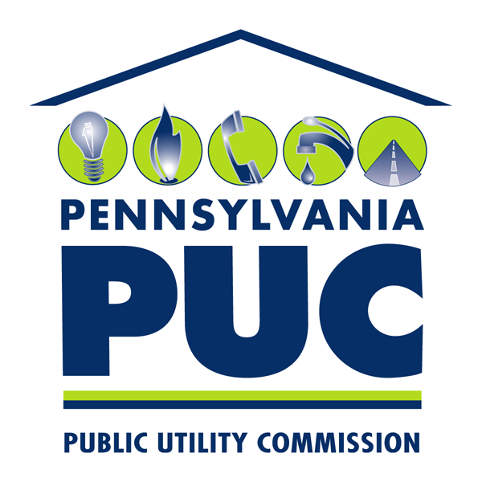 | COMMONWEALTH OF PENNSYLVANIA  PENNSYLVANIA PUBLIC UTILITY COMMISSION  P.O. BOX 3265, HARRISBURG, PA 17105-3265 | IN REPLY PLEASE REFER TO OUR FILE  M-2009-2093217

January 26, 2011

Gary A. Jack
Assistant General Counsel
Duquesne Light Company
16th Floor, 411 Seventh Avenue
Pittsburgh, PA 15219

Re: Duquesne Light Company Conservation Service Provider Contract
with Navigant Consulting, Inc., (Evaluation, Measurement and Verification of its Energy Efficiency and Conservation and Demand Response Plan) Docket No. M-2009-2093217

Dear Mr. Jack:

This letter acknowledges that Commission staff have reviewed Duquesne Light Company’s (Duquesne) proposed Conservation Service Provider (CSP) contract with Navigant Consulting, Inc., filed with the Commission on December 15, 2010 for its Evaluation, Measurement and Verification of its Energy Efficiency and Conservation and Demand Response Plan.

The Implementation Order, inter alia, required all Electric Distribution Companies (EDCs) subject to Act 129 to submit, for Commission review, all proposed contracts with
CSPs. The Commission may order modification of these proposed contracts.
66 Pa. C.S. § 2806.1(a)(8). The Commission, in its Energy Efficiency and Conservation Program Implementation Order at Docket No. M-2008-2069887 (entered January 16,
2009), delegated its authority to review and approve CSP contracts to Commission Staff.

Duquesne is advised that the proposed CSP contract filed on December 15, 2010
is approved. This approval does not constitute approval of any component of Duquesne’s Energy Efficiency and Conservation Plan. Furthermore, we note that approval of this filing does not constitute a determination that such a filing is consistent with the public interest and that the associated costs or expenses are reasonable or prudent for the purposes of cost recovery. These issues will be addressed by the Commission in any appropriate plan approval and cost recovery proceedings.

Please direct any questions to Anthony J. Rametta, Energy Division Supervisor, Bureau of Fixed Utility Services, at (717) 787-2359 or Patricia T. Wiedt, Assistant Counsel, Law Bureau, at (717) 787-5755.
Sincerely,

Rosemary Chiavetta
Secretary

cc: Elaine McDonald, FUS
Anthony J. Rametta, FUS
Kriss Brown, Law Bureau
Patricia T. Wiedt, Law Bureau
Kathy Aunkst, Secretary’s Bureau
Irwin A. Popowsky, Esquire, OCA
William R. Lloyd, Esquire, OSBA

